成绩：

实 验 报 告

课程名称： | 虚拟现实建模技术
实验项目： | Mesh编程构建分形立体几何模型
姓 名：
专 业： | 计算机科学与技术
班 级：
学 号：

计算机科学与技术学院

2021年 4 月 24 日
实验项目名称：Mesh编程构建分形立体几何模型
一、实验目的
通过MESH编程绘制分形立体几何模型
二、实验内容
1、简述本实验所用到的Unity组件
2、设计通过Mesh编程实现分形平面几何模型的方法（算法）
3、通过Mesh编程绘制分形平面几何模型（带注释的程序）
三、实验原理
1. 谢尔宾斯基三棱锥
首先给定4个顶点，定一个三棱锥框架，根据每边中点获取新点的坐标，用三个中点和一个给定顶点递归，直至递归结束画出当前三棱锥。
2.创建子对象方式，可以用于各种物体
首先手动赋值mesh一个物体，给定创建次数，利用创建子对象的方式，在每个面上创建6个子物体，物体边长大小逐个递减。
3.正方体
首先给定8个顶点，定一个立方体框架。根据每条边长三等分及相应计算可划分出小正方体对应坐标，以此类推递归下去。
四、实验结果及源代码
1. 谢尔宾斯基三棱锥
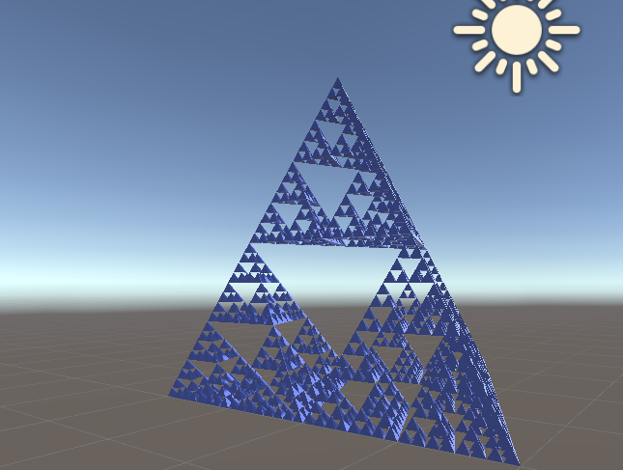
代码：
using System.Collections;
using System.Collections.Generic;
using UnityEngine;

public class Tri3d : MonoBehaviour
{
public int n;//递归层数
public Material mat;
public List<Vector3> ver = new List<Vector3>();
public List<int> tri = new List<int>();
int num = 0;
// Start is called before the first frame update
void Start()
{
Draw(n);
}

// Update is called once per frame
void Update()
{

}
private void Triangle3d(Vector3 a, Vector3 b, Vector3 c, Vector3 o, int n)
{
//求三棱锥每条边中点
Vector3 OA = new Vector3((o.x + a.x) / 2, (o.y + a.y) / 2, (o.z + a.z) / 2);
Vector3 OB = new Vector3((o.x + b.x) / 2, (o.y + b.y) / 2, (o.z + b.z) / 2);
Vector3 OC = new Vector3((o.x + c.x) / 2, (o.y + c.y) / 2, (o.z + c.z) / 2);
Vector3 AB = new Vector3((a.x + b.x) / 2, (a.y + b.y) / 2, (a.z + b.z) / 2);
Vector3 AC = new Vector3((a.x + c.x) / 2, (a.y + c.y) / 2, (a.z + c.z) / 2);
Vector3 BC = new Vector3((b.x + c.x) / 2, (b.y + c.y) / 2, (b.z + c.z) / 2);

//利用每边中点和一个顶点递归
if (n > 0)
{
Triangle3d(OA, OB, OC, o, n - 1);
Triangle3d(a, AB, AC, OA, n - 1);
Triangle3d(AB, BC, b, OB, n - 1);
Triangle3d(AC, c, BC, OC, n - 1);
}

//当前层递归结束则添加点
else
{
ver.Add(a);
tri.Add(num++);
ver.Add(b);
tri.Add(num++);
ver.Add(c);
tri.Add(num++);
ver.Add(c);
tri.Add(num++);
ver.Add(b);
tri.Add(num++);
ver.Add(a);
tri.Add(num++);

ver.Add(b);
tri.Add(num++);
ver.Add(o);
tri.Add(num++);
ver.Add(a);
tri.Add(num++);
ver.Add(a);
tri.Add(num++);
ver.Add(o);
tri.Add(num++);
ver.Add(b);
tri.Add(num++);

ver.Add(b);
tri.Add(num++);
ver.Add(o);
tri.Add(num++);
ver.Add(c);
tri.Add(num++);
ver.Add(c);
tri.Add(num++);
ver.Add(o);
tri.Add(num++);
ver.Add(b);
tri.Add(num++);

ver.Add(a);
tri.Add(num++);
ver.Add(o);
tri.Add(num++);
ver.Add(c);
tri.Add(num++);
ver.Add(c);
tri.Add(num++);
ver.Add(o);
tri.Add(num++);
ver.Add(a);
tri.Add(num++);
}
}

private void Draw(int n)
{
gameObject.AddComponent<MeshFilter>();
Mesh mesh = GetComponent<MeshFilter>().mesh;
gameObject.AddComponent<MeshRenderer>();
gameObject.GetComponent<MeshRenderer>().material = mat;

//初始三棱锥框架
Vector3 A = new Vector3(0, 0, 0);
Vector3 B = new Vector3(0, 0, 4);
Vector3 C = new Vector3(3.5f, 0, 2);
Vector3 O = new Vector3(0.3f, 3.2f, 2);

Triangle3d(A, B, C, O, n);
mesh.vertices = ver.ToArray();
mesh.triangles = tri.ToArray();
mesh.RecalculateNormals();
}
}

2.子对象
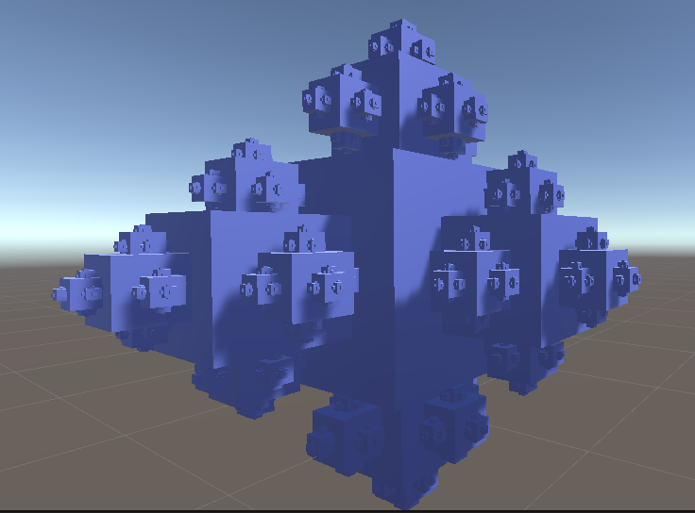
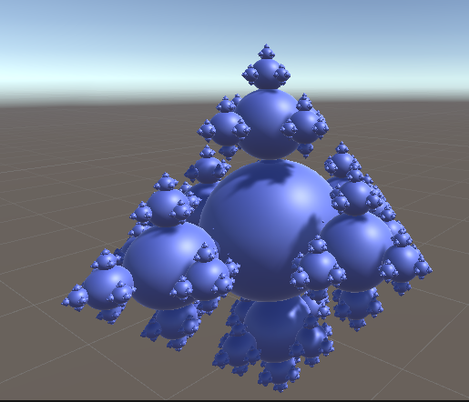
using System.Collections;
using System.Collections.Generic;
using UnityEngine;

public class Fractal : MonoBehaviour
{
public Mesh Mesh;
public Material Material;

public int Depth;//控制创建子对象次数
public float Size;

private Vector3[] pos = { Vector3.left, Vector3.right, Vector3.up, Vector3.down, Vector3.forward ,Vector3.back};
private Vector3[] rotate = { Vector3.down, Vector3.up, Vector3.left, Vector3.right, Vector3.zero,Vector3.one };

// Use this for initialization
private void Start()
{
gameObject.AddComponent<MeshFilter>().mesh = Mesh;
gameObject.AddComponent<MeshRenderer>().material = Material;
if (Depth <= 0)
return;
//计算偏移量控制下一个物体的位置
var posOffset = Size + Size/ 2f;

//每个面创建6个子对象
for (int i = 0; i < 6; i++)
{
//每个子物体调用Initialize()相对于父类进行大小、位置、角度变化
new GameObject("Fractal Child").AddComponent<Fractal>().Initialize(this, Size, pos[i] * posOffset, rotate[i] * 90);
}
}

public void Initialize(Fractal parent, float size, Vector3 pos, Vector3 rot)
{
//在工作区手动赋值父对象的mesh
Mesh = parent.Mesh;
Material = parent.Material;
Depth = parent.Depth - 1;
Size = (float)(size*0.9);
//相对于父类的位置、大小、旋转变化
transform.SetParent(parent.transform);
transform.localPosition = pos;
transform.localEulerAngles = rot;
transform.localScale = Vector3.one * size;
}
}

3.正方体
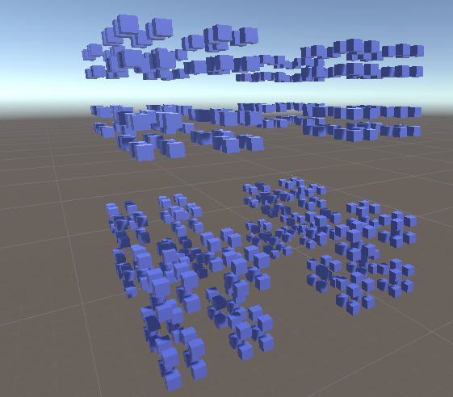
using System.Collections;
using System.Collections.Generic;
using UnityEngine;

public class rect3d : MonoBehaviour
{
public int m;//递归层数
public Material mat;
public List<Vector3> ver = new List<Vector3>();
public List<int> tri = new List<int>();
int num = 0;//边计数
// Start is called before the first frame update
void Start()
{
Draw(m);
}

// Update is called once per frame
void Update()
{

}

public void Cube3d(Vector3 a, Vector3 b, Vector3 c, Vector3 d, Vector3 e, Vector3 f, Vector3 g, Vector3 h, float BIAN, int n)
{
float Bian = BIAN / 3;//三等分

//从顺时针确定4个小正方体
Vector3 a1 = new Vector3(a.x, a.y + 2 * Bian, a.z);
Vector3 b1 = new Vector3(b.x, b.y + 2 * Bian, b.z - 2 * Bian);
Vector3 c1 = new Vector3(c.x - 2 * Bian, c.y + 2 * Bian, c.z - 2 * Bian);
Vector3 d1 = new Vector3(d.x - 2 * Bian, d.y + 2 * Bian, d.z);
Vector3 e1 = new Vector3(e.x, e.y, e.z);
Vector3 f1 = new Vector3(f.x, f.y, f.z - 2 * Bian);
Vector3 g1 = new Vector3(g.x - 2 * Bian, g.y, g.z - 2 * Bian);
Vector3 h1 = new Vector3(h.x - 2 * Bian, h.y, h.z);

Vector3 a2 = new Vector3(a.x, a.y + 2 * Bian, a.z + 2 * Bian);
Vector3 b2 = new Vector3(b.x, b.y + 2 * Bian, b.z);
Vector3 c2 = new Vector3(c.x - 2 * Bian, c.y + 2 * Bian, c.z);
Vector3 d2 = new Vector3(d.x - 2 * Bian, d.y + 2 * Bian, d.z + 2 * Bian);
Vector3 e2 = new Vector3(e.x, e.y, e.z + 2 * Bian);
Vector3 f2 = new Vector3(f.x, f.y, f.z);
Vector3 g2 = new Vector3(g.x - 2 * Bian, g.y, g.z);
Vector3 h2 = new Vector3(h.x - 2 * Bian, h.y, h.z + 2 * Bian);

Vector3 a3 = new Vector3(a.x + 2 * Bian, a.y + 2 * Bian, a.z + 2 * Bian);
Vector3 b3 = new Vector3(b.x + 2 * Bian, b.y + 2 * Bian, b.z);
Vector3 c3 = new Vector3(c.x, c.y + 2 * Bian, c.z);
Vector3 d3 = new Vector3(d.x, d.y + 2 * Bian, d.z + 2 * Bian);
Vector3 e3 = new Vector3(e.x + 2 * Bian, e.y, e.z + 2 * Bian);
Vector3 f3 = new Vector3(f.x + 2 * Bian, f.y, f.z);
Vector3 g3 = new Vector3(g.x, g.y, g.z);
Vector3 h3 = new Vector3(h.x, h.y, h.z + 2 * Bian);

Vector3 a4 = new Vector3(a.x + 2 * Bian, a.y + 2 * Bian, a.z);
Vector3 b4 = new Vector3(b.x + 2 * Bian, (b.y + 2 * Bian), (b.z - 2 * Bian));
Vector3 c4 = new Vector3(c.x, c.y + 2 * Bian, (c.z - 2 * Bian));
Vector3 d4 = new Vector3(d.x, (d.y + 2 * Bian), d.z);
Vector3 e4 = new Vector3((e.x + 2 * Bian), e.y, e.z);
Vector3 f4 = new Vector3((f.x + 2 * Bian), f.y, (f.z - 2 * Bian));
Vector3 g4 = new Vector3(g.x, g.y, (g.z - 2 * Bian));
Vector3 h4 = new Vector3(h.x, h.y, h.z);

// //从下表面确定4个小正方体
Vector3 a5 = new Vector3(a.x, a.y, a.z);
Vector3 b5 = new Vector3(b.x, b.y, (b.z - 2 * Bian));
Vector3 c5 = new Vector3((c.x - 2 * Bian), c.y, (c.z - 2 * Bian));
Vector3 d5 = new Vector3((d.x - 2 * Bian), d.y, d.z);
Vector3 e5 = new Vector3(e.x, (e.y - 2 * Bian), e.z);
Vector3 f5 = new Vector3(f.x, (f.y - 2 * Bian), (f.z - 2 * Bian));
Vector3 g5 = new Vector3((g.x - 2 * Bian), (g.y - 2 * Bian), (g.z - 2 * Bian));
Vector3 h5 = new Vector3((h.x - 2 * Bian), (h.y - 2 * Bian), h.z);

Vector3 a6 = new Vector3(a.x, a.y, (a.z + 2 * Bian));
Vector3 b6 = new Vector3(b.x, b.y, b.z);
Vector3 c6 = new Vector3((c.x - 2 * Bian), c.y, c.z);
Vector3 d6 = new Vector3((d.x - 2 * Bian), d.y, (d.z + 2 * Bian));
Vector3 e6 = new Vector3(e.x, (e.y - 2 * Bian), (e.z + 2 * Bian));
Vector3 f6 = new Vector3(f.x, (f.y - 2 * Bian), f.z);
Vector3 g6 = new Vector3((g.x - 2 * Bian), (g.y - 2 * Bian), g.z);
Vector3 h6 = new Vector3((h.x - 2 * Bian), (h.y - 2 * Bian), (h.z + 2 * Bian));

Vector3 a7 = new Vector3((a.x + 2 * Bian), a.y, (a.z + 2 * Bian));
Vector3 b7 = new Vector3((b.x + 2 * Bian), b.y, b.z);
Vector3 c7 = new Vector3(c.x, c.y, c.z);
Vector3 d7 = new Vector3(d.x, d.y, (d.z + 2 * Bian));
Vector3 e7 = new Vector3((e.x + 2 * Bian), (e.y - 2 * Bian), (e.z + 2 * Bian));
Vector3 f7 = new Vector3((f.x + 2 * Bian), (f.y - 2 * Bian), f.z);
Vector3 g7 = new Vector3(g.x, (g.y - 2 * Bian), g.z);
Vector3 h7 = new Vector3(h.x, (h.y - 2 * Bian), (h.z + 2 * Bian));

Vector3 a8 = new Vector3((a.x + 2 * Bian), a.y, a.z);
Vector3 b8 = new Vector3((b.x + 2 * Bian), b.y, (b.z - 2 * Bian));
Vector3 c8 = new Vector3(c.x, c.y, (c.z - 2 * Bian));
Vector3 d8 = new Vector3(d.x, d.y, d.z);
Vector3 e8 = new Vector3((e.x + 2 * Bian), (e.y - 2 * Bian), e.z);
Vector3 f8 = new Vector3((f.x + 2 * Bian), (f.y - 2 * Bian), (f.z - 2 * Bian));
Vector3 g8 = new Vector3(g.x, (g.y - 2 * Bian), (g.z - 2 * Bian));
Vector3 h8 = new Vector3(h.x, (h.y - 2 * Bian), h.z);

if (n > 0)
{
//上表面
Cube3d(a1, b1, c1, d1, e1, f1, g1, h1, Bian, n - 1);
Cube3d(a2, b2, c2, d2, e2, f2, g2, h2, Bian, n - 1);
Cube3d(a3, b3, c3, d3, e3, f3, g3, h3, Bian, n - 1);
Cube3d(a4, b4, c4, d4, e4, f4, g4, h4, Bian, n - 1);
//下表面
Cube3d(a5, b5, c5, d5, e5, f5, g5, h5, Bian, n - 1);
Cube3d(a6, b6, c6, d6, e6, f6, g6, h6, Bian, n - 1);
Cube3d(a7, b7, c7, d7, e7, f7, g7, h7, Bian, n - 1);
Cube3d(a8, b8, c8, d8, e8, f8, g8, h8, Bian, n - 1);

}
else
{
ver.Add(a);
tri.Add(num++);
ver.Add(b);
tri.Add(num++);
ver.Add(c);
tri.Add(num++);
ver.Add(c);
tri.Add(num++);
ver.Add(b);
tri.Add(num++);
ver.Add(a);
tri.Add(num++);

ver.Add(a);
tri.Add(num++);
ver.Add(c);
tri.Add(num++);
ver.Add(d);
tri.Add(num++);
ver.Add(d);
tri.Add(num++);
ver.Add(c);
tri.Add(num++);
ver.Add(a);
tri.Add(num++);

ver.Add(e);
tri.Add(num++);
ver.Add(f);
tri.Add(num++);
ver.Add(g);
tri.Add(num++);
ver.Add(g);
tri.Add(num++);
ver.Add(f);
tri.Add(num++);
ver.Add(e);
tri.Add(num++);

ver.Add(e);
tri.Add(num++);
ver.Add(g);
tri.Add(num++);
ver.Add(h);
tri.Add(num++);
ver.Add(h);
tri.Add(num++);
ver.Add(g);
tri.Add(num++);
ver.Add(e);
tri.Add(num++);

ver.Add(g);
tri.Add(num++);
ver.Add(f);
tri.Add(num++);
ver.Add(b);
tri.Add(num++);
ver.Add(b);
tri.Add(num++);
ver.Add(f);
tri.Add(num++);
ver.Add(g);
tri.Add(num++);

ver.Add(g);
tri.Add(num++);
ver.Add(b);
tri.Add(num++);
ver.Add(c);
tri.Add(num++);
ver.Add(c);
tri.Add(num++);
ver.Add(b);
tri.Add(num++);
ver.Add(g);
tri.Add(num++);

ver.Add(h);
tri.Add(num++);
ver.Add(e);
tri.Add(num++);
ver.Add(a);
tri.Add(num++);
ver.Add(a);
tri.Add(num++);
ver.Add(e);
tri.Add(num++);
ver.Add(h);
tri.Add(num++);

ver.Add(h);
tri.Add(num++);
ver.Add(a);
tri.Add(num++);
ver.Add(d);
tri.Add(num++);
ver.Add(d);
tri.Add(num++);
ver.Add(a);
tri.Add(num++);
ver.Add(h);
tri.Add(num++);

ver.Add(h);
tri.Add(num++);
ver.Add(g);
tri.Add(num++);
ver.Add(c);
tri.Add(num++);
ver.Add(c);
tri.Add(num++);
ver.Add(g);
tri.Add(num++);
ver.Add(h);
tri.Add(num++);

ver.Add(h);
tri.Add(num++);
ver.Add(c);
tri.Add(num++);
ver.Add(d);
tri.Add(num++);
ver.Add(d);
tri.Add(num++);
ver.Add(c);
tri.Add(num++);
ver.Add(h);
tri.Add(num++);

ver.Add(e);
tri.Add(num++);
ver.Add(f);
tri.Add(num++);
ver.Add(b);
tri.Add(num++);
ver.Add(b);
tri.Add(num++);
ver.Add(f);
tri.Add(num++);
ver.Add(e);
tri.Add(num++);

ver.Add(e);
tri.Add(num++);
ver.Add(b);
tri.Add(num++);
ver.Add(a);
tri.Add(num++);
ver.Add(a);
tri.Add(num++);
ver.Add(b);
tri.Add(num++);
ver.Add(e);
tri.Add(num++);
}
}

public void Draw(int n)
{
gameObject.AddComponent<MeshFilter>();
Mesh mesh = GetComponent<MeshFilter>().mesh;
gameObject.AddComponent<MeshRenderer>();
gameObject.GetComponent<MeshRenderer>().material = mat;

//初始正方体框架
Vector3 a = new Vector3(0, 0, 10);
Vector3 b = new Vector3(0, 0, 19);
Vector3 c = new Vector3(9, 0, 19);
Vector3 d = new Vector3(9, 0, 10);
Vector3 e = new Vector3(0, 9, 10);
Vector3 f = new Vector3(0, 9, 19);
Vector3 g = new Vector3(9, 9, 19);
Vector3 h = new Vector3(9, 9, 10);

//初始边长
float L = 9;
Cube3d(a, b, c, d, e, f, g, h, L, m);

mesh.vertices = ver.ToArray();
mesh.triangles = tri.ToArray();
mesh.RecalculateNormals();
}
}

